Title of the presentation (14 pt, Times New Roman, bold, centered)
Lecturer Underlinedª, Coauthors^{b}
ªName and corresponding address of workplace/department 10 pt, italics, centered
^{b}Name and corresponding address of workplace/department 10 pt, italics, centered
Edges: Up and down 3 cm, left and right 2,5 cm (gutter: 0 cm) Normal style: 11 pt, justified, 1.5-line space, 1,0 cm indent from the left in the first line, interval space between paragraphs 0 pt. Citations should be given in square brackets [1]. Among citations in order dash [1-3], among citations not in order comma [1,3] should be given.

The length of the abstract for the conference proceedings should be 5-7 pages in English.

Figures and tables should be placed in the text, middle-aligned, with 1-1 empty row before and after the main text. The title of the figures should be placed under the figure, 10 pt, middle aligned. In the text, the reference to Figure 1. should be in the same format as below the figure (Figure 1).
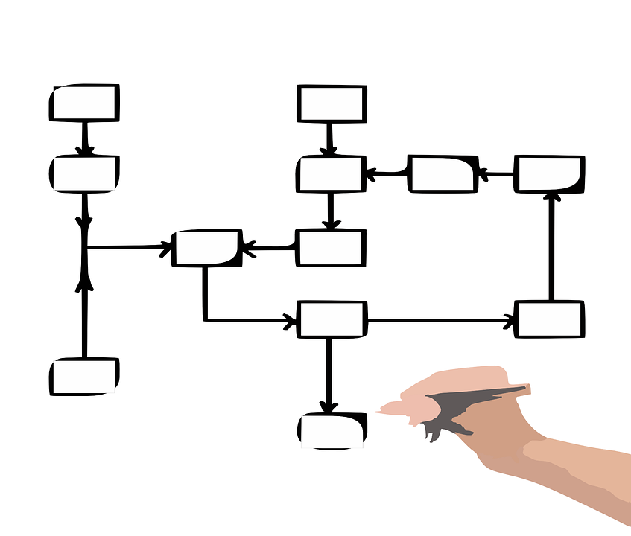
Figure 1. The right format of the figure’s subtitling, above the label, 6 pt should be set

In the case of tables, the title should be placed above the table, middle-aligned, 10 pt

1. Table. The right format of the table’s subtitling
one | zero | zero
1 | 0 | 0

Citations should be given at the very end of the abstract. Number of them in square brackets, without indent, then with 0.75 cm indent full names of the authors in the following format:

[1] X. Surname, Y. Z. Surname: Name of the journal, year (volume), first page-last page.
[2] H. T. Smith et al.: Nature, 1985 (318), 162-163.

Acknowledgment following the citations after 2 empty rows, 10 pt, Times New Roman, bold, no indent

